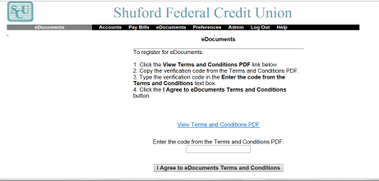
Signing up for Electronic Statements
Click on the ONLINE SERVICES tab
Click LOGON HERE
Click ENROLLMENT at the top of the page
READ and complete all requested information, including the eDOCUMENT link. (See below)

When your statement is available for viewing you will be notified via email as stated below:
memberservice@shuford Shuford Federal Credit Union eDocuments greetings (your name) A new statement is now available for viewing.
You will then log into your SCU Internet Site and click eDocuments then click the document you wish to view.

If your request for Enrollment or a request for Contact Us is submitted on a Weekend, Federal Holiday, Weather Related closing, or after 4:00 pm, a Shuford Federal Credit Union representative will process the request on the next business day.

